Management by Objectives

The term Management by Objectives was coined by Peter Drucker in 1954.

The process of setting objectives in the organization to give a sense of direction to the employees is called as Management by Objectives. It refers to the process of setting goals for the employees so that they know what they are supposed to do at the workplace. Management by Objectives defines roles and responsibilities for the employees and help them chalk out their future course of action in the organization. It guides the employees to deliver their level best and achieve the targets within the stipulated time frame.

### Need for Management by Objectives (MBO)

1. The Management by Objectives process helps the employees to understand their duties at the workplace.
2. KRAs are designed for each employee as per their interest, specialization and educational qualification.
3. The employees are clear as to what is expected out of them.
4. Management by Objectives process leads to satisfied employees. It avoids job mismatch and unnecessary confusions later on.
5. Employees in their own way contribute to the achievement of the goals and objectives of the organization. Every employee has his own role at the workplace. Each one feels indispensable for the organization and eventually develops a feeling of loyalty towards the organization. They tend to stick to the organization for a longer span of time and contribute effectively. They enjoy at the workplace and do not treat work as a burden.
6. Management by Objectives ensures effective communication amongst the employees. It leads to a positive ambience at the workplace.
7. Management by Objectives leads to well defined hierarchies at the workplace. It ensures transparency at all levels. A supervisor of any organization would never directly interact with the Managing Director in case of queries. He would first meet his reporting boss who would then pass on the message to his senior and so on. Every one is clear about his position in the organization.
8. The MBO Process leads to highly motivated and committed employees.
9. The MBO Process sets a benchmark for every employee. The superiors set targets for each of the team members. Each employee is given a list of specific tasks.

Management by Exception

Managers cannot control every organizational activity. This is neither desirable nor possible within the frame of time, money and resource constraints. If actual performance conforms to planned performance, the matter need not be brought to the notice of top managers. Even when the deviation is not significant (when it is within the range of control), the matter may not be reported to top managers.

However, if deviations are significant (beyond the acceptable range of errors), they should be reported up the hierarchy for managerial action. These deviations may be exceptionally good or bad situations. The principle of ‘management by exception’ states that managers should concentrate only on significant deviations rather than each and every organizational activity. “The more the managers concentrate control efforts on significant exceptions, the more efficient will be the results of their control.”

The principle of ‘management by exception’ is closely related to the principle of ‘critical point control’. While critical points determine the areas or elements where control should be exercised, the ‘exception principle’ determines the deviations occurring at the critical points. It, thus, serves as a performance appraisal technique which identifies significant deviations in the ‘critical points’ and reduces their chances of recurrence.

#### Merits of ‘Management by Exception’:

The principle of ‘management by exception’ has the following merits:

1. It saves time, effort and money as superiors deal with only exceptional deviations.
2. It leads to development of lower-level managers as they learn to deal with simple and routine problems.
3. It leads to optimum attainment of organizational goals by categorizing the deviations between significant (those that significantly affect organizational objectives) and insignificant (those that do not require top managerial attention).
4. It leads to optimum utilization of resources as they are concentrated in areas that need managerial attention.

US vs. Japanese style of management

#### Comparison of Managers:

Japanese managers are quite different from other managers generally and from American managers specifically. Japanese managers (when compared to American managers) are more apt to embrace reciprocal participative attitudes and values and to perceive higher levels of self actualization flowing from their roles and positions. Japanese managers, more than American managers, have internalized organizational goals concerning high productivity, organizational growth and organizational stability. The behavioural relevance of personal goals achievement and creativity is higher for Japanese managers while the behavioural relevance of job satisfaction and individuality is higher for American managers.

#### Comparison of Workers:

Japanese workers have greater trust and acceptance of management decisions concerning application of practices and policies than do American workers. Japanese workers value working at high levels of capacity and assisting other workers to a greater extent than do American workers, and that this difference is increasing over time. High level of work effort and commitment, organizational involvement and cooperation, acceptance, and trust in management policies and practices — all are the norm of Japanese workers; they are not for American workers.

#### Comparison of Societies:

Japanese people endorse social norms whereby uncertainty is reduced through systems of rules leading to stability. The Japanese tend to view themselves in collective terms rather than in individual terms. These are the elements of Japanese social norms which are very consistent with theory Z of management. Americans score in the opposite direction, high on individuality and low on uncertainty avoidance and it is hardly consistent with theory Z management practices.

### Conclusions and implications:

The real differences between Japan and the United States in general social values and norms and in manager and worker belief systems concerning work raise serious questions about widespread transferability of Theory Z management to the United States.

McKinsey 7-S Model

* The McKinsey 7-S Model is a tool designed to help business owners and managers understand how aligned their organization is, and where it can be approved.
* The model is most often used as an organizational analysis tool to assess and monitor changes in the internal situation of an organization.
* It is based on the theory that, for an organization to perform well, these seven elements need to be aligned and mutually reinforcing.
* The model can be used to help identify what needs to be realigned to improve performance, or to maintain performance during other types of change.

The McKinsey 7-S Model is a tool designed to help business owners and managers understand how aligned their organization is, and where it can be improved. As you might guess from the title, there are seven elements which make up this model – strategy, structure, systems, shared values, skills, style, and staff. Each of these elements it vital to your success, yet each needs its own time and attention to function properly. Only when these separate parts of your organization are able to come together can you be confident that you are on the right path.

To help you better understand this model, it is divided into two categories – hard elements, and soft elements. Three of the factors are categorized on the hard elements side, with four on the soft elements side. Let’s take a look at each of these separately to better understand how the McKinsey 7-S Model can influence your organization.

**The Hard Elements**

The three factors which are considered as ‘hard’ elements under this model are strategy, structure, and systems. For most managers, these are going to be the elements that are easier to understand and quantify. In fact, these are probably the areas that you are currently spending most of your time, even if you don’t think about them as such.

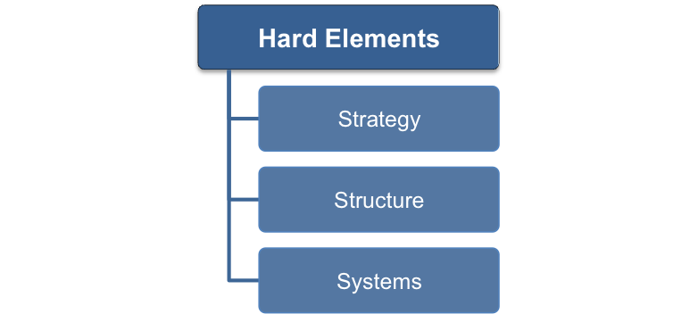

These are the classic elements of business operations and your work on a daily basis very likely relates to one or more of these areas.

**Strategy:** This is a high-level perspective on the business and how you plan to rise above your competitors over time. Most likely, you will be able to draw most of your strategy from the business plan that should have been drafted when you were first getting started. In some cases, your strategy could be defined by the sub-section of the business in which your work. For example, if you are the accounting manager within a larger organization, your strategy may relate to how you can best provide the accurate data that is required by those above you – as opposed to having it relate the business operations as a whole.

**Structure:** The structure element is another one that you probably have a handle on already. Structure is often visualized in the form of an organizational chart or other document that outlines who reports to whom. This structure could deal in terms of the whole organization, or simply a department within the company, such as the accounting department from our previous example.

**Systems:** How the job gets done. This is the work that is taking place on a regular basis to keep the business operating and moving forward. Most likely, systems is where you spend the vast majority of your time as a manager. Making sure all of your employees are working on the right projects, and getting them done in time, is the life of a leader within any business. Without systems that function properly, none of the rest of the model will get you anywhere.

It should be pretty easy to get a handle on these hard elements of the model. However, just by thinking of them in this way and making sure each is aligned to the other, your management style could be improved or refined.

## The Soft Elements

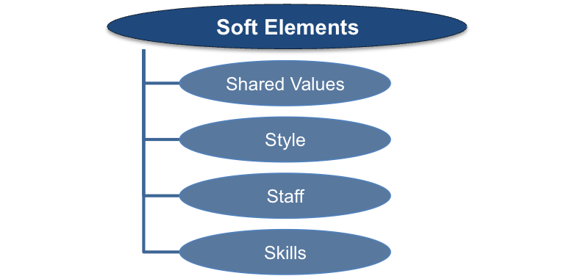

The soft elements within this model are somewhat harder to define, and definitely more difficult to quantify. They are no less important, however, and the good leader will give them just as much time and attention as the previous group.

**Shared Values:** Think of this point as the overall culture of the company, and the purpose behind everything that is done. The shared values of an organization should stretch to all employees, to create a feeling of cohesiveness and camaraderie.

**Style:** How are you going to lead your team? The style of leadership that you use should fall in line with both the culture of the organization, and the needs of your team. There are many different leadership styles employed by managers depending on the situation, so you will need to craft your own approach to the job as you see best fit based on the circumstances around you.

**Staff:** Understanding the strengths and weaknesses of your team is a classic leadership responsibility – but you also need to know how to then get the most from them while also developing their skills along the way. A good leader will constantly be improving their team so they are stronger tomorrow than they were today.

**Skills:** In many ways, this point goes along with staff in terms of knowing what you can get done in-house with the skills you have available to you. You never want to ask someone on your team to do something they aren’t capable of, so having a strong understanding of the skills within your staff is something that you should prioritize.

Self-Management

Self-Management, simply stated, is an organizational model wherein the traditional functions of a manager (planning, coordinating, controlling, staffing and directing) are pushed out to all participants in the organization instead of just to a select few.  Each member of the organization is personally responsible for forging their own personal relationships, planning their own work, coordinating their actions with other members, acquiring requisite resources to accomplish their mission, and for taking corrective action with respect to other members when needed.

This manifests itself as a total absence of formal hierarchy.  Formal hierarchy implies that there are those within the organization who have authority to direct the actions of others, and that there are others within the organization who have only limited authority.  The principles of Self-Management acknowledge that those who would traditionally be viewed as the "employees" are, in fact, the ones who have the greatest insight into the management of their day-to-day functions and who are, further, in the best position to take immediate action when circumstances demand a response or a change in course.  Those principles extend the rights and resources required to take action and make decisions out to those who are best suited to take action and make decisions rather than arbitrarily extending those rights to a select few individuals who we anoint with the title of "manager".